Given the following code, draw the recursive trace in memory and indicate what the final result will be for the function call below:

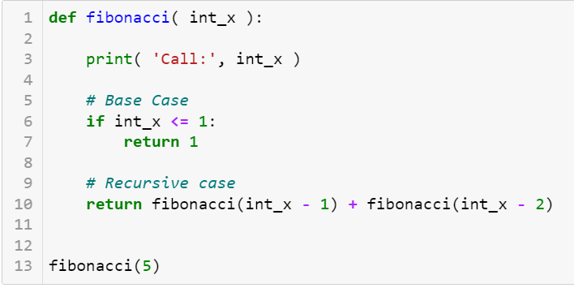

Given the following code, draw the recursive trace in memory and indicate what the final result will be for the function call below:

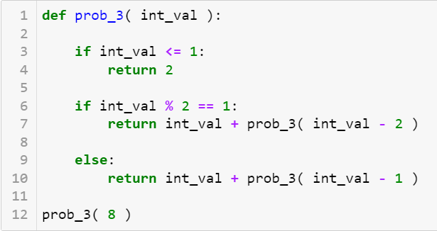

Given the following code, draw the recursive trace in memory and indicate what the final result will be for the function call below:

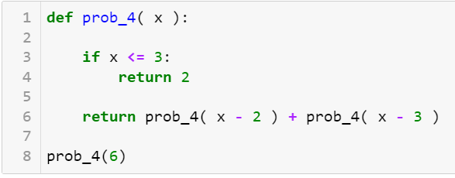

Given the following code, draw the recursive trace in memory and indicate what the final result will be for the function call below:

